Architecture Vision
Citizen Services Mobile Application

Version 0.1
For
<CLIENT>

Contents
1 Introduction 5
1.1 Purpose 5
1.2 Scope 5
1.3 Definitions 5
1.4 References 6
1.5 Documentation Roadmap 6
2 Executive Summary 8
2.1 Key Decisions 8
2.2 Key Risks and Open Issues 8
3 Architectural Drivers 9
3.1 Business Case 9
3.1.1 Business Goals 10
3.1.2 Major Features 10
3.2 Use Case Model 11
3.2.1 Use Case View <View Name> 11
3.3 Design Constraints 12
3.4 Quality Attribute Scenarios 13
4 Solution Architecture 15
4.1 Big Picture 15
4.1.1 Solution Context 15
4.1.2 Solution Decomposition 16
4.2 Design Concerns 18
4.3 Development Technology Stack 19
4.3.1 Development Languages, Frameworks, and Libraries 19
4.3.2 Development Tools 19
4.3.3 External Integration Points 20
5 Implementation Roadmap 21
5.1 Implementation Deliverables 21
5.2 Implementation Milestones 21
5.3 Estimate 22
5.3.1 Assumptions and Limitations 22
5.3.2 Estimate 22
5.4 Team 22
5.4.1 Team Skillset 23
5.4.2 Team Structure 23

Revision History
Date | Version | Description | Author
 | <x.x> | <details> | <name>
 | <x.x> | Approved | <name>

Introduction

Purpose
This Architecture Vision elicits the significant architecture drivers such as business, functional, nonfunctional requirements and constraints, defines architecture, and develops a roadmap for Single Entry implementation. The document is intended as a primary technical guidance into solution implementation for the development team.
The solution architecture is designed following the guiding principles outlined in Appendix A – Architecture Design Methodology.

Scope
The document describes the proposed Single Entry architecture towards development of the solution that will satisfy business, functional, non-functional requirements and constraints provided by the Client. This Architecture Vision covers the following information:
- Significant architectural drivers for the Solution
- Proposed software architecture of the solution based on these drivers
- Technology stack and environment definitions
- Operations specific perspectives
- Development road map and high level estimates for effort, team size and skill sets.

Definitions
The Definitions section lists the acronyms and terms used in this document which might possess lesser familiarity or double meaning to the reader.
(Fill the table if you have definitions)
# | Term | Definition

References
The References section provides a complete list of all the documents referenced elsewhere in this document.
(Fill the table if you have references)
# | Version | Date | Document Name | Published by
 | <x.x> | <mm/dd/yyyy> | <Document Name> | <Publishing Organization>

Documentation Roadmap
This section guides into the Architecture Vision document structure to help find the information of interest.
- Executive Summary speaks about the proposed architecture on the highest level and covers:
  - Key Decisions about the architectural and operational choices made for the solution
  - Key Risks and Open Issues detected with the analysis of the available context, requirements, and proposed decisions
- Architectural Drivers elicits the known essential requirements and constraints for the solution to design which play key role in forming archectural decisions and overall architecture.
  - Business Case describes the solution from the business standpoint including major features
  - Service Level Agreement defines the important technical constraints and guarantees under which the solution will be serviced to its clients
  - Use Case Model lists the key Use Cases for the designed solution
  - Domain Model shows the key business entities with attributes and relationships between them.
  - Design Constraints include business, resource, technical and other constraints accounted for in the architecture of the solution.
  - Quality Attribute Scenarios are a set of the testable scenarios clarifying non-functional requirements for the system quality attributes such as performance, maintainability, and others.
- Solution Architecture defines the proposed architecture as a set of architectural views in the format defined in Appendix C – How View is Documented.
  - Big Picture shows the solution architectural context, high level decomposition into components, and followed reference architecture.
  - Development Technology Stack selects the tools, frameworks, libraries, external services and other technologies the solution implementation will rely on.
- Implementation Roadmap proposes the plan for solution implementation including:
  - Implementation Deliverables expected to be implemented and delivered at the implementation phase.
  - Implementation Milestones tied to the project timeline
  - Estimate of complexity/size, effort, schedules for the implementation
  - Team skillset and structure based on the technology, competence, and schedule requirements

Executive Summary
The section Executive Summary highlights key architectural decisions made for the solution described in Business Case. These decisions are defined and discussed in depth in Solution Architecture while Implementation Roadmap lays out the proposed milestones, estimates, and team to implement the provided architecture vision.
This section also summarizes the key business and technical risks related to the solution implementation. These risks are uncovered in depth in the rest of the document.

Key Decisions
The section outlines key design decisions about the solution including the architecture big picture and most essential technologies and external services to rely on.
(provide a short description of the main decisions you’ve made solutioning the architecture)
The solution will be implemented as a cloud based Java web service and deployed to the Cloud Platform Provider XYZ using it’s A, B, C services. The structured data will be stored in the scalable cloud RDBMS storage provided by the Cloud Platform Provider with multy-AZ replication to ensure data availability and backup as required by the solution’s SLA. The solution will be integrated as a REST-ful client with the third-party service ABC to store and retrieve the unstructured blob data.

Key Risks and Open Issues
The section lists the key risks related to the solution design and implementation. It also lists key open issues where architectural decisions have not been made yet or are likely to change.
(add identified risks and a mitigation strategy for them in the table below)
Risk Description | Mitigation Strategy
Solution relies on the third-party services to implement its functionality under SLA. As a result the solution service performance and availability can be at risk | - Enter into the business agreement with the third-party service provider.  - Select the backup provider  - Implement the fail-over strategy
<risk description> | <mitigation strategy description>

Architectural Drivers
The section captures significant requirements driving the solution architecture and road map. The requirements which are not influencing the solution architecture in major ways and low level requirement details and scenarios are typically excluded from this section and can be found in the requirement specification or the product backlogs.

Business Case
The section lays out the business case for the solution Citizen Services Mobile Application.
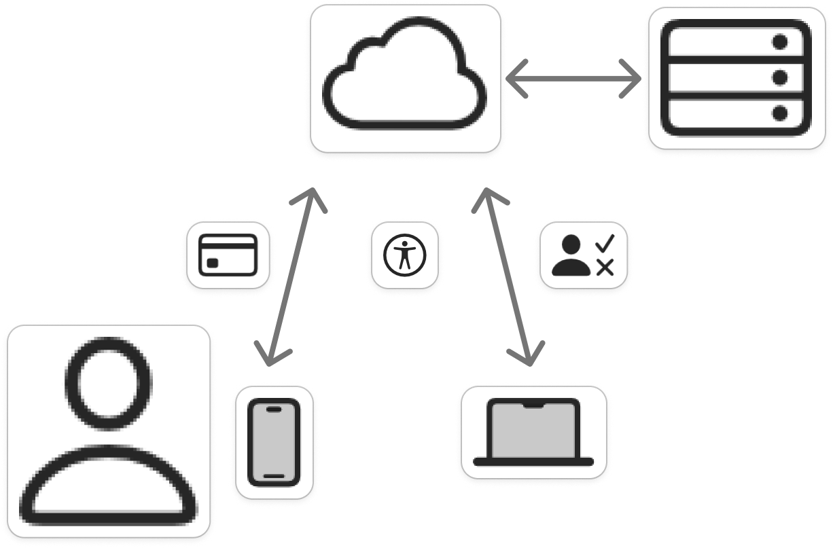
Figure 1. Business level view of Citizen Services Mobile Application
The envisioned Citizen Services solution enables residents to securely access and manage key municipal services through a unified mobile and web platform. Citizens will be able to submit permit applications, make bill payments, and track public works requests directly from their mobile devices, while municipal staff will access enhanced reporting and administrative tools via desktop browsers. All citizen transactions, requests, and status updates will be synchronized with existing legacy systems through a secure cloud integration layer. Data and service logs will be stored within a compliant government cloud environment to ensure security, accessibility, and continuity.

Business Goals
The section enumerates essential business goals for the solution
# | Description
BG-1 | Modernize the municipality’s current approach to citizen service delivery by consolidating fragmented service portals into a unified, mobile-first platform.
BG-2 | Improve operational efficiency and reduce administrative overhead through increased citizen self-service adoption and automation of routine transactions.
BG-3 | Enhance citizen satisfaction and engagement by providing a seamless, intuitive, and accessible mobile experience across iOS and Android devices.
BG-4 | Achieve measurable cost savings (target: $550K per year) by decreasing reliance on call centers and in-person interactions.
BG-5 | Strengthen data collection and analytics capabilities for better decision-making and performance measurement across departments.
BG-6 | Ensure compliance with government security, privacy, and accessibility standards (e.g., WCAG 2.1 AA, Auth0 SSO integration).
BG-7 | Enable scalable digital transformation by integrating with existing legacy backend systems (billing, permitting, public works) via secure APIs.

Major Features
The section enumerates solution major features.
# | Description
F-1 | Centralized transaction data storage and management on the cloud, enabling unified access to all municipal service records.
F-2 | Seamless integration with legacy backend systems via secure API gateway.
F-3 | Mobile-first design providing consistent and responsive user experience across iOS, Android, and web platforms.
F-4 | Secure authentication and access control through Single Sign-On (SSO) using the corporate Auth0 framework.
F-5 | Real-time tracking and notifications for service requests, permit applications, and bill payments.
F-6 | Integrated online payment system supporting multiple payment methods with full encryption compliance.
F-7 | Comprehensive administrative dashboard for municipal staff to manage requests, workflows, and performance analytics and create reports for analisys.
F-8 | Municipal staff should have access to requests, and instruments to accept or decline any request.

Use Case Model

Use Case Non-authenticated Citizen authentefication

View Context
The interaction outlined in the feature 4 happens between the Non-authenticated Citizen and service auth page

Representation
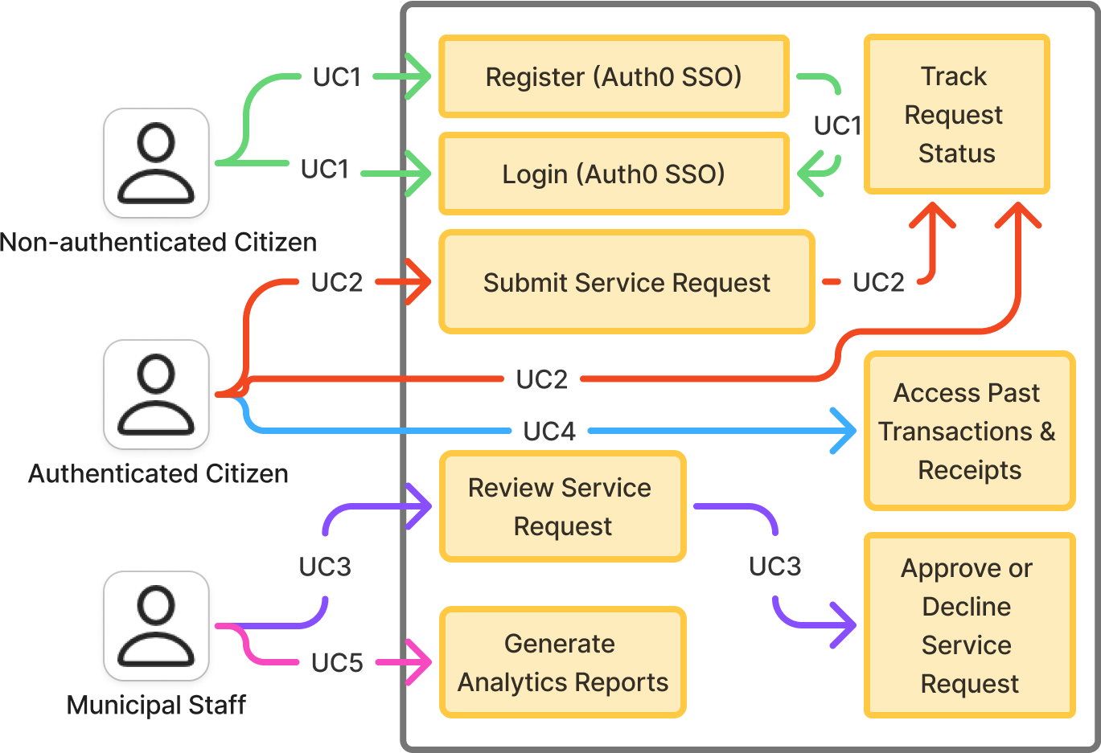
Figure 1. Non-authenticated Citizen authentefication
This view defines primary Use Cases for the feature 4.

Element Catalog
# | Name | Description
ACT-1 | Non-authenticated Citizen | User, which use our service for first time, or which was loged out
UC-1 | Citizen already have an account | User logs into the system.
UC-1 | Citizen don’t have an account | User register in service, and than logs into the system

Use Case Authenticated Citizen submit request

View Context
The interaction outlined in the feature 5 happens between the Authenticated Citizen and request service

Representation
Figure 2. Authenticated Citizen submit request
This view defines primary Use Cases for the feature 5.

Element Catalog
# | Name | Description
ACT-1 | Authenticated Citizen | User which successfully loged into our service
UC-2 | Citizen submit service request and track its status | User submit his request and can follow his status by system
UC-2 | Citizen track status of any request submitted by Citizen | User following status of all his own requests

Use Case Municipal Staff review citizen requests

View Context
The interaction outlined in the feature 8 happens between the Municipal Staff and user requests

Representation
Figure 3. Municipal Staff review citizen requests
This view defines primary Use Cases for the feature 8.

Element Catalog
# | Name | Description
ACT-1 | Municipal Staff | Staff which can manage citizen requests
UC-3 | Municipal Staff with proper competency can review, accept or deny citizen submitted requests | To make a proper conection with citizens, their submitted requests can be accepted or denied by Municipal staff

Use Case Authenticated Citizen can access past transactions and receipts

View Context
The interaction outlined in the feature 1 happens between the Authenticated Citizen and and cloud database

Representation
Figure 4. Authenticated Citizen can access past transactions and receipts
This view defines primary Use Cases for the feature 1.

Element Catalog
# | Name | Description
ACT-1 | Authenticated Citizen | User which successfully loged into our service
UC-4 | Citizen can access to past request and receipts | User can get information about any of his own past request or receipt

Use Case Municipal Staff get Analytics Reports

View Context
The interaction outlined in the feature 7 happens between the Authenticated Citizen and request service

Representation
Figure 5. Municipal Staff get Analytics Reports
This view defines primary Use Cases for the feature 7.

Element Catalog
# | Name | Description
ACT-1 | Municipal Staff | Staff which can manage citizen requests
UC-5 | Municipal Staff get Analytics Reports | Municipal staff can generate Analytics report for analisys. It can be not only about services but also about statistic

Design Constraints
The section lists the constraints accounted for in the designed solution. These can be of business, technical, resource, and other types.
# | Description
CONST-1 | A minimum of 1,000 simultaneous users must be supported under normal operating conditions to ensure scalability and adequate performance for high-volume citizen access.
CONST-2 | Time to market must be within 10-month, including all phases of design, development, testing, and deployment, to align with the fiscal budget and municipal service improvement goals.
CONST-3 | The application must fully comply with governmental security and data protection standards, including data encryption, secure authentication (SSO), and audit logging.
CONST-4 | The system must meet accessibility standards (WCAG 2.1 AA) to guarantee usability for all citizens, including those with disabilities.
CONST-5 | Integration with three legacy backend systems (Billing, Permitting, and Public Works) is mandatory for the initial release to ensure complete service continuity.
CONST-6 | Mobile apps must be native (iOS and Android 4+), and the administrative dashboard must be accessible through modern web browsers.
CONST-7 | All data backups and transaction logs must be stored in a compliant cloud storage environment to meet retention and recovery policy requirements.

Quality Attribute Scenarios
A Quality Attribute Scenario is an unambiguous and testable requirement for one or more Solution Quality Attributes such as Performance, Usability, Maintainability and others. The scenario consists of six parts: Source of Stimulus, Stimulus, Environment, Artifact, Response, testable and accurate Response Measure.
This section lists and prioritizes the scenarios pertinent to the designed solution.
# | Quality Attribute | Scenario | Business Priority | Related  To
QA-1 | Security  (credentials transport security) | At all times, the credentials entered by the user during login are transferred to the server over an encrypted, secure channel (HTTPS/TLS 1.3) without the possibility of interception or sniffing by a third party. | High | UC-1
QA-2 | Usability  (easiness of payment) | When logged in and navigated to the service page, no more than 3 clicks needed to start processing user request. | Medium | UC-2
QA-3 | Performance (system responsiveness) | Under normal operating load (up to 1,000 concurrent users), the system must return search results or service request status updates within 2 seconds. | High | UC-2, UC-3, UC-4
QA-4 | Availability (system uptime) | The production environment must maintain 99.5% uptime excluding planned maintenance, ensuring continuous citizen access to services. | High | UC-1, UC-2, UC-3, UC-4
QA-5 | Accessibility (WCAG 2.1 AA compliance) | All application interfaces must pass accessibility validation tools, ensuring that citizens with disabilities can perform all supported functions. | High | UC-1, UC-2, UC-4
QA-6 | Maintainability (code and configuration management) | All application components must be containerized and deployed using CI/CD pipelines, allowing bug fixes or feature updates to be released to production within 12 hours after approval. | Medium | UC-1, UC-2, UC-3, UC-4,  UC-5

Scenario: QA-1
Quality Attributes: Security
Business Priority: High
Related To: UC-1
Description: At all times, the credentials entered by the user during login are transferred to the server over an encrypted, secure channel (HTTPS/TLS 1.3) without the possibility of interception or sniffing by a third party.
Environment: Normal operation conditions
Source
Login Form

Artifact
Client-Server Channel

Response Measure
Traffic encrypted and protected from sniffing

Stimulus
Response
Enter and submit credentials
Credentials transferred to server
Environment: The system is online and accessible from outside

Solution Architecture
The section Solution Architecture is primary for the Architecture Vision document. It defines and reasons about the solution architecture design based on requirements and constraints identified in the section Architectural Drivers.

Big Picture
The section includes a list of architectural views covering the designed solution along with the context it runs in on the high level.

Solution Context

Intent
The view defines the primary solution components collaborating with the external systems and services. It is driven by the Business Case.

Representation
(add your C4 context diagram below)
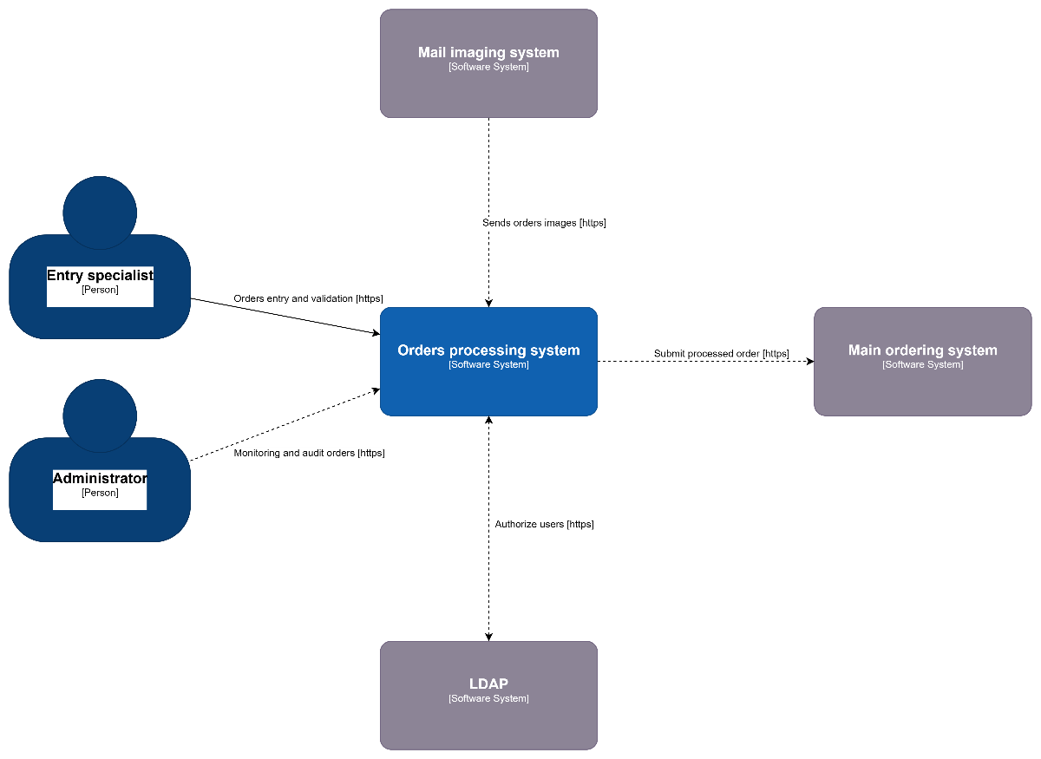

Figure 4. Solution Context diagram
(explain your context diagram)

Element Catalog
Table of annotated elements
(annotate elements from your diagram in the table below)
Name | Description
Cloud Based Solution | Responsible for implementing the REST API to serve data on request from the mobile and web clients
Element2 | Responsible for a, b, c
Element3 | Responsible for a, b, c
<element name> | <element description and responsibilities>

Solution Decomposition

Intent
The view defines the runtime decomposition of the server-side part of the solution. It is driven by the Business Case and the architecture best practices applicable to the cloud-based applications.

Context
The view context is defined by the view Solution Context where this section represents the decomposition of the system using the Containers view.

Representation
(add your container diagram below)
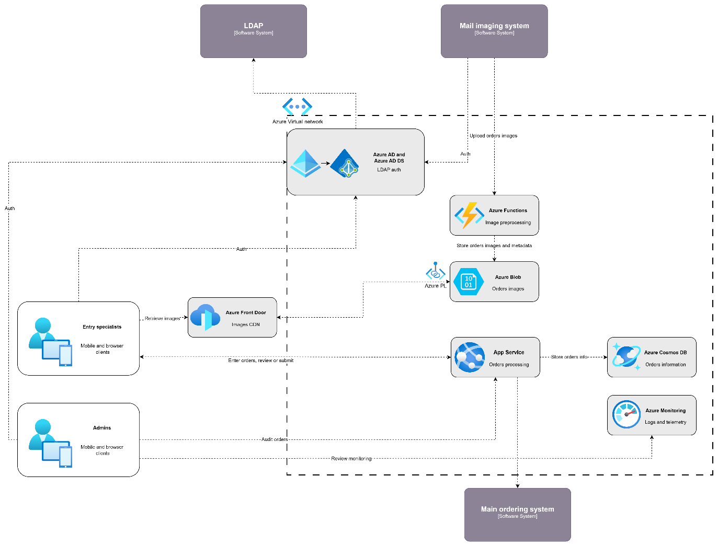

Figure 5. Cloud Solution Container view
(explain your container diagram)
The cloud based part of the solution is decomposed into several parts documented below combining several standard architectural patterns applicable to the highly loaded cloud based SaaS applications: Load Balancer, Data Cache, Background Process, Shared Storage, and Static Content Provider. The subsection resoning provides detailed discussion of these choices.

Element Catalog
Table of annotated elements
(annotate elements from the container diagram here)
# | Description
Element1 | Responsible for a, b, c
Element2 | Responsible for a, b, c
Element3 | Responsible for a, b, c
<element name> | <element description and responsibilities>

Design Concerns
The section lists the concerns defined for the solution.
(list your design concerns/ architecturally significant requirements in the table below)
# | Description
CONC-1 | <concern description>
CONC-2 | <concern description>
CONC-3 | <concern description>
CONC-4 | <concern description>
<concern id> | <concern description>

Development Technology Stack
The section includes a list of decisions on tech stack, frameworks, libs, tools, external services, etc.

Development Languages, Frameworks, and Libraries

Intent
The view lists the set of programming languages, frameworks, and libraries the solution implementation will depend on.

Context
The context is provided by the view Solution Context.

Element Catalog
Table of annotated elements
(list all technologies, frameworks, libraries that have to be used in the solution in the table below)
Name | Version | Description
Framework1 | x.x | Responsible for a, b, c
Library2 | 3.0-RC1 | Responsible for a, b, c
Library3 | x.x.x.x | Responsible for a, b, c
<name> | <version> | <description and responsibilities>

Development Tools

Intent
The view lists the set of tools the development team will rely upon in solution implementation.

Context
The context is provided by the view Solution Context.

Element Catalog
Table of annotated elements
(list all the tools, like IDEs, SAAS, plugins, etc that will be used during the development)
Name | Version | Description
Framework1 | x.x | Responsible for a, b, c
Library2 | 3.0-RC1 | Responsible for a, b, c
Library3 | x.x.x.x | Responsible for a, b, c
<name> | <version> | <description and responsibilities>

External Integration Points

Intent
The view lists the set of programming languages, frameworks, and libraries the solution implementation will depend on.

Context
The context is provided by the view Solution Context.

Element Catalog
(list all the integration points if you have any 3-rd party integration in the table below)
Name | Version | Description
Framework1 | x.x | Responsible for a, b, c
Library2 | 3.0-RC1 | Responsible for a, b, c
Library3 | x.x.x.x | Responsible for a, b, c
<name> | <version> | <description and responsibilities>

Implementation Roadmap
Implementation Roadmap defines the solution implementation road map including list of implementation deliverables, major milestones, effort estimates, and recommended team skillset, structure, and size.

Implementation Deliverables
The implemented solution will include the following parts as deliverables:
(list your deliverables in the table below)
Name | Refer to Requirements | Refer to Design
Application 1
Service 2
Mobile Client 3
Production Deployment 4

Implementation Milestones
The section proposes the major milestones to guide the solution implementation.
(decide and list main milestones for your project in the table below)
Milestone | Description | Outcomes
M0 | Project bootstrap | - Dev Team ramped up  - Dev and Testing Environment set up  - Project Skeleton built
M1 | Main application with web front-end development | - Alpha version of the web application  - Deployment to the staging
M2 | Development and stabilization of the web application, development of the deployment and monitoring procedures, release | - Release 1.0 of the application prepared and stable  - DevOps framework functional  - Release 1.0 goes to production

Estimate
The Estimate section provides the estimates for the solution implementation based on the proposed architecture and selected estimation methodology.

Assumptions and Limitations
This section describes the known limitations imposed by selected platform, technology, hardware, operating system, third party components, etc. which might affect implementation effort and schedule estimates.
(Describe assumptions and possible limitations that could affect delivery timelines in the table below)
# | Description | Responsible
A1 | Assumption 1 | <Client Name>
A2 | Assumption 2 | SoftServe Team
L1 | Limitation 1 | <Third Party Name>

Estimate
The Estimate section provides effort and, optionally, schedule estimates for the implementation based on the architecture proposed in this Vision document using the WBS approach.
(list delivery items and estimation for these items to be ready)
# | Item | Complexity | Min Effort | Max Effort
Total:

Team
The Team section outlines the proposed team skillset and structure based on the proposed technology stack and estimates.

Team Skillset
The section defines skills required from the different team member roles to implement the solution.
(describe team roles and required skillsets for these roles)
Role | Skillset
Business Analyst | - Business domain 1  - Business domain 2
Backend Developer | - Programming Language 1  - Technology 2  - Framework 3  - Tool 4  - Standard 5
UI Developer | - Programming Language 1  - Technology 2  - Framework 3  - Tool 4  - Standard 5
DevOps Engineer | - Programming Language 1  - Technology 2  - Framework 3  - Tool 4  - Standard 5

Team Structure
The section proposes a team/sub-team structure and work allocation for the implementation phase.
(describe teams and their responsibilities)

Core Team
The core team is responsible for:
- Development of <Component 1>
- Development of <Component 2>
- Support of <Application 1>

Role | Responsibility | Count | FTE
Project Manager | - Project management (coordinate the team, status reporting, communications with the Client team)  - Gap analysis | 1 | 0.5
Business Analyst | - Business analysis  - Business requirements specification  - Software requirements specification | 1 | 1.0
Solutions Architect | - System analysis and design  - System requirements specification | 1 | 0.2
Technical Leader | - Technical leadership and communication  - SCRUM Master  - Code Reviews  - Backend implementation | 1 | 1.0
Sr. Backend Developer | - Technical communication  - Code reviews  - Backend implementation | 2 | 1.0
Jr. Backend Developer | - Backend implementation | 3 | 1.0
Int. UI Developer | - Web frontend design and implementation  - UX prototyping | 3 | 1.0

DevOps Team
The DevOps team is responsible for:
- Configuration of <Environment 1>
- Configuration of <Environment 2>
- Deployment and runtime monitoring of <Application 1>

Role | Responsibility | Count | FTE
DevOps Architect | - Operations analysis and design | 1 | 0.2
Int. DevOps Engineer | - System deployment  - Environment setup  - Production operations support | 3 | 1.0

